MSIM 441/541 & ECE 406/506
Computer Graphics & Visualization

Programming Assignment Two
Transportation Simulation
Assigned October 22, Due 12:00 PM November 19

1. Overview
3D computer graphics and visualization generate highly realistic objects and environments that are essential in many applications such as video games and virtual environments for simulations. 3D computer graphics requires in-depth understanding many mathematical concepts such as geometry, linear algebra, and trigonometry, and strong programming skills to develop effective and efficient data structures, algorithms, and implementations. In addition to visual representations, many simulations and games also contain complex logic that controls dynamic entities such as human characters, vehicles, weapons, and their interactions. In this programming assignment, you will develop a transportation simulation (Figure 1) that contains a simplified intersection (including traffic lights and surveillance cameras), two roads, and a vehicle. You will generate the control logic of the traffic signals, vehicle driving simulation, and multiple views of the simulation from different perspectives.

Programmers in the real world rarely develop an entire application totally from scratch; instead, it is most likely that the programmer will develop an application based on an earlier version of the application or use some other existing software libraries. This is one reason that the instructor has developed a base project for this programming assignment and will provide it to the class as your starter code. The second consideration for providing a base project is the difficulty of the project if developed from scratch (and the difficulty of 3D graphics programming in general).
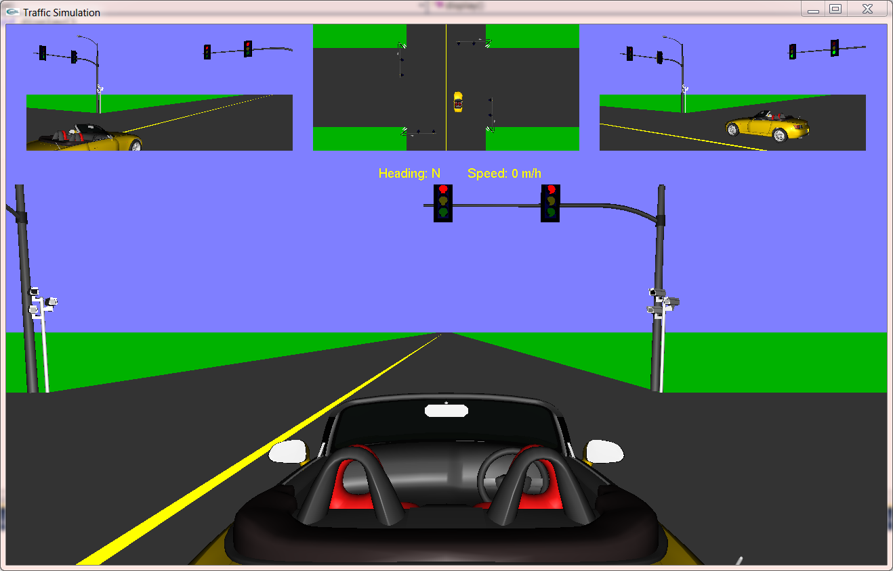
Figure 1. Transportation Simulation

2. Objectives
Objectives of this assignment are divided into two categories: 1) Review and Enhancement; and 2) Learning Outcomes. Review and Enhancement include knowledge and skills that you are supposed to have already known before taking this course and give you an opportunity to enhance them. Learning Outcomes contain the new knowledge and skills you are expected to learn from this assignment.

2.1 Review and Enhancement
- File input/output (I/O)
- String operations using stringstream class
- Structures and classes in C++.
- Class inheritance and virtual methods
- Classes and algorithms provided by the C++ Standard Template Library (STL) (in particular, vector and map)
- Program debugging techniques

2.2 Learning Outcomes
- Understand the Alias obj file format for storing 3D models (meshes)
- Understand the existing code (ObjModel class) for parsing obj files.
- Simple use of 3D modeling software tools such as Maya
- Define a derived class (TrafficLight) of ObjModel to represent the traffic lights and implement the newly defined methods in TrafficLight.
- Build a virtual world by placing entities using proper units and transformations (scaling, rotation, and translation) and/or generating entities directly using OpenGL primitives.
- Understand the mathematics behind affine transformations.
- Determine proper camera locations and orientations, especially the third-person camera.
- Determine proper camera projections.
- Generate multiple viewports.
- Develop the control logic for traffic lights at a simplified intersection (using a state machine).
- Define and use OpenGL display lists.
- Understanding and use of at least the following OpenGL related concepts.
  - gluLookAt()
  - gluPerspective()
  - glViewport()
  - glPushMatrix()
  - glPopMatrix()
  - glTranslatef()
  - glRotatef()
  - glScalef()
  - glNewList()
  - glEndList()
  - glCallList()
  - glutTimerFunc()

3. Tasks
3.1Understanding the Virtual World
The virtual world (or scene, level) in this simulation is an area of 2000m × 2000m centered at an intersection. The unit for the world frame is meter, with x axis pointing east, y up (sky), and z south. The center of the intersection is the origin of the world frame. The two roads are both two-way 4-lane roads (2 lanes/one way, with a lane width of 5 meters). See the notes included in this assignment to fully understand the world frame and object positions.

The intersection is a simplified one in that it only allows straight through traffic, i.e., a vehicle is not allowed to make turns at the intersection. The base project only contains a yellow centerline that divides the 2-way traffic along the north-south direction. Make the following changes to the base project.
- The intersection should not have the yellow line, so you need to remove the yellow centerline inside the intersection.
- Add two more yellow centerlines along the west-east direction and again, no yellow centerline should appear inside the intersection.
- Add dashed white lines as lane dividers for traffic in the same direction. Follow the US federal standard provided by the following link:
http://mutcd.fhwa.dot.gov/htm/2003r1r2/part3/part3a.htm#section3A05. Dash white lines should appear on all roads except inside the intersection. This task is required for MSIM 541/ECE 506 and is optional for extra credits for MSIM 441/ECE 406.

3.2 Traffic Lights and Surveillance Cameras
Each corner of the intersection has a traffic light pole and a surveillance camera. The base project placed only one traffic light pole and a surveillance camera. Add the remaining traffic lights and cameras. Be careful about their positions and orientations. Answer the following questions.
- Where (which part) is the origin of the traffic light pole in its local frame? You need to use a 3D modeling tool such as Maya to open the file.
- When placing the traffic light and surveillance camera, you need to use glTranslatef() and glRotatef(). Explain their purposes. Why glTranslatef() is called before glRotatef() in your code?
- In the base code, glScalef() was called for drawing the traffic light, but not used for drawing the surveillance camera. Explain why.
3.3 Three-dimensional (3D) Model File Formats and Traffic Signal Control Logic
Each traffic light contains three signals: green, yellow, and red, and each signal has two modes: on and off. The 3D model files for the traffic light are TrafficLight.obj and TrafficLight.mtl and by default all the three signals are on. To turn off a signal, you need to change the color (i.e., reduce the intensity of the color) of the mesh that represents the specific signal. Thus, you need to understand the file formats for storing 3D models.

A. OBJ File Format
The Alias obj file format is a relatively simple file format for storing 3D meshes. Wikipedia provides a short introduction of the obj file format that should be sufficient for this assignment.
- http://en.wikipedia.org/wiki/Wavefront_.obj_file
The above URL also points to other links that contain more detailed information about the obj format and examples. An obj file contains the geometry information of a 3D model and it has an associated mtl file that contains the material information of the same object.

The key information contained in an obj file includes vertex positions, normal directions, texture coordinates, face definitions using indices of vertices, normal, and texture coordinates, group definitions, and material specifications. The mtl file defines the material properties in terms of ambient reflection, diffusive reflection, specular reflection, and illumination models. Both obj and mtl files are ASCII text files. Use Microsoft Visual Studio or any other text editors to open the sample obj and mtl files included in this assignment. Study carefully different types of lines in obj and mtl files and think how you would develop a parser to read obj and mtl files.
B. OBJ File Parser
The instructor has written several structures and classes for parsing Obj files and they are included in the base project. Read the code carefully and answer the following questions.
- List all the files (names) involved in the Obj parser.
- List all the data structures used by the ObjModel class for storing mesh geometry and explain them briefly.
- The C++ STL class vector is used extensively in the Obj parser. Explain its functionalities and advantages. What method is used in the base project to add an element to a vector?
- How is the C++ STL class map used in the base project (i.e., list the variables that are map and explain their usage)? If map is not used, what data structure(s) would you use to represent same information and perform same functions?
- What OpenGL primitives are used to draw the mesh geometry? What are the three display modes supported by the class ObjModel?
- The class ObjModel also calculates the center and bounding box using GetCenter() and GetBoundingBox(). Explain their meanings. Although they are not directly used in this project, can you suggest some possible uses in other applications?

C. TrafficLight Class
The ObjModel class developed by the instructor supports only static models the attributes (e.g., materials and normal) of which do not change dynamically during runtime. However, the traffic lights change their signal colors regularly. In order to do this, the normal way is to find the geometry of the signals and change their material properties accordingly (i.e., change the material from Material A to Material B). This project will utilize a different and simpler approach based on some prior knowledge of the model TrafficLight in which the signals are the only geometry that use their materials. For example, the material _Yellow_ is used only by the yellow signal. Thus, to represent the two states (on and off) of the yellow signal, we can just change the properties of the material _Yellow_ instead of making two materials _Yellow_On_ and _Yellow_Off_inside the model file.

The instructor has defined a new class TrafficLight and you need to implement two methods that have been declared (setMaterials() and setSignal()) based on what was just discussed above. To this end, you need to find the material names used by the signals in the material file and change the material properties in your code on the fly. The time is 5 seconds for green signal, 1 second for yellow, and 6 for red.

3.4 Driving Simulation and Third Person Camera
After preparing the terrain and traffic lights, now it is time to include a car in the simulation. Load the car model in a 3D modeling tool such as Maya. Note that z axis is the forward direction of the car in its local frame. In order to model the movement of the car, we need to keep a variable that represents the car’s forward direction in the world frame. At each simulation time step, we just add the displacement (corresponding to the speed) along the forward direction to the current car position. Also note that the forward direction is changed by left or right turns. Use glutTimerFunc() to determine a time step for your simulation and the following keys to control your car.
- Up: accelerate
- Down: decelerate (can possibly change the shift to reverse).
- Left: turn left
- Right: turn right
- R: reset the car to its initial position, orientation, and speed (0)
- B: break (and the car stops immediately)
- Escape: exit the program.

A third-person camera is a camera that follows the player in a simulation or game. In this assignment, you are the driver, and the third-person camera should follow you (or the car because you and the car are together). The third-person camera should be placed along the –z direction in the car local frame (i.e., back of the car), pointing to the front of the car. Explain how you determine the parameter values used in gluLookAt() for this third person camera and generate the camera in your code. Compute the heading and speed of the car and display the information in your simulation window.

3.5 Adding More Cameras and Viewports
In addition to the third-person camera for the car, you need to generate three additional cameras and put them in different viewports. The first two cameras are used to simulate two surveillance cameras and the third camera provides a top (bird’s) view of the intersection. Make sure that you set the parameters for glViewport(), gluPerspective(), and gluLookAt() properly so that when the window size changes, all viewports still display nicely without distortion and other problems.

3.6 Extra Credits (Easy)
Find more 3D models online or generate some simple models using GLUT commands and place the objects in your virtual world to form a more complex world. The exact extra credits are dependent on your effort.

4. Coding (60 points)
Exercise good coding practices, such as naming variables meaningfully and properly, including comments of key classes, variables, functions, and code segments, and using indentations and proper spacing between tokens (e.g., variables, operators). Points will be deducted for lack of comments or bad formatting (e.g., no indentation or large blank spaces in the code). The following is the grade allocation for different tasks or functionalities of your program.
- Road pavement markings: 5 points
- Traffic lights and surveillance cameras: 10 points
- Traffic light control logic: 10 points
- Driving simulation and third-person camera: 20 points
- Other cameras and viewports: 10 points
- Interactivity: 5 points (e.g., automatic determination of position and size of viewports that adapt well to window size changes)

5. Report (40 points)
The report should contain at least the following sections and use the same formatting in this assignment description or other professional formats. Points will be deducted for improper formatting.
- Audience: The reader of your report is a software engineer who will continue your project because you have been just promoted to a higher-level position in your company. The software engineer didn’t know anything about your project previously.
- Introduction (5 points): overview of the assignment, such as background, objectives, and brief summary of what you have done for this assignment. Don’t repeat the assignment description verbatim.
- Program Design (15 points)
You will use doxygen to generate the documentation (help) file for your code. You need to generate documentation for all classes, class variables, class methods, and internal implementations of critical methods, for all types of access modifiers (public, protected, and private). Your documentation should include source code, class diagrams, call graphs, and caller graphs. Your documentation should be contained in a single .chm file.
- Results (15 points): Describe what you have done for each task specified in Section 3: Tasks. Include results and necessary screen captures for each task. Answer the questions in the task if any. Include one or more video captures.
- Conclusion and Discussion (5 points): Discuss your accomplishments, learning outcomes, and difficulties and how you can do better for this assignment. Feel free to suggest other ideas for this assignment and discuss other relevant topics.

6. Deliverables
Submit your report and your entire Visual Studio solution with the data files you used. Compress everything into one file and submit that file.

